# CS 340 README Template

## *About the Project/Project Title*

*The application will allow users to access the database for the Python Project to search and filter for specific animals in the database. The user will search for animals in the database with the help of the Grazioso Salvarethe requester to display the dashboard. The user then can filter searches along with using geolocation mapping to see specific location of animals. This project allows users to interact with the dashboard along with displaying a geolocation of the animals chosen.*

## *Motivation*

*The project’s motivation is to create and allow users to search the animals database records. The project database is used to display records in a database to simplify database management.*

## *Getting Started:*

1. *Enter Mongo and access the csv file aac_shelter_outvome.csv and initialize connection to the MongoDB.*
2. *Create an admin user and another user for them to access the animal database.*
3. *Access the Jupyter Notebook.*
4. *Download Project Two.ipynb.*
5. *Download AnimalShelter.py.*
6. *Upload files to Jupyter Notebook.*
7. *Type in specific address to connect to the dashboard.*

## *Installation*

* *You must download the current version of Python.*
* *Have access to the MongoDB database.*
* *Jupyter Notebook Access*

## *Usage*

### *Code Example:*

Dash board:

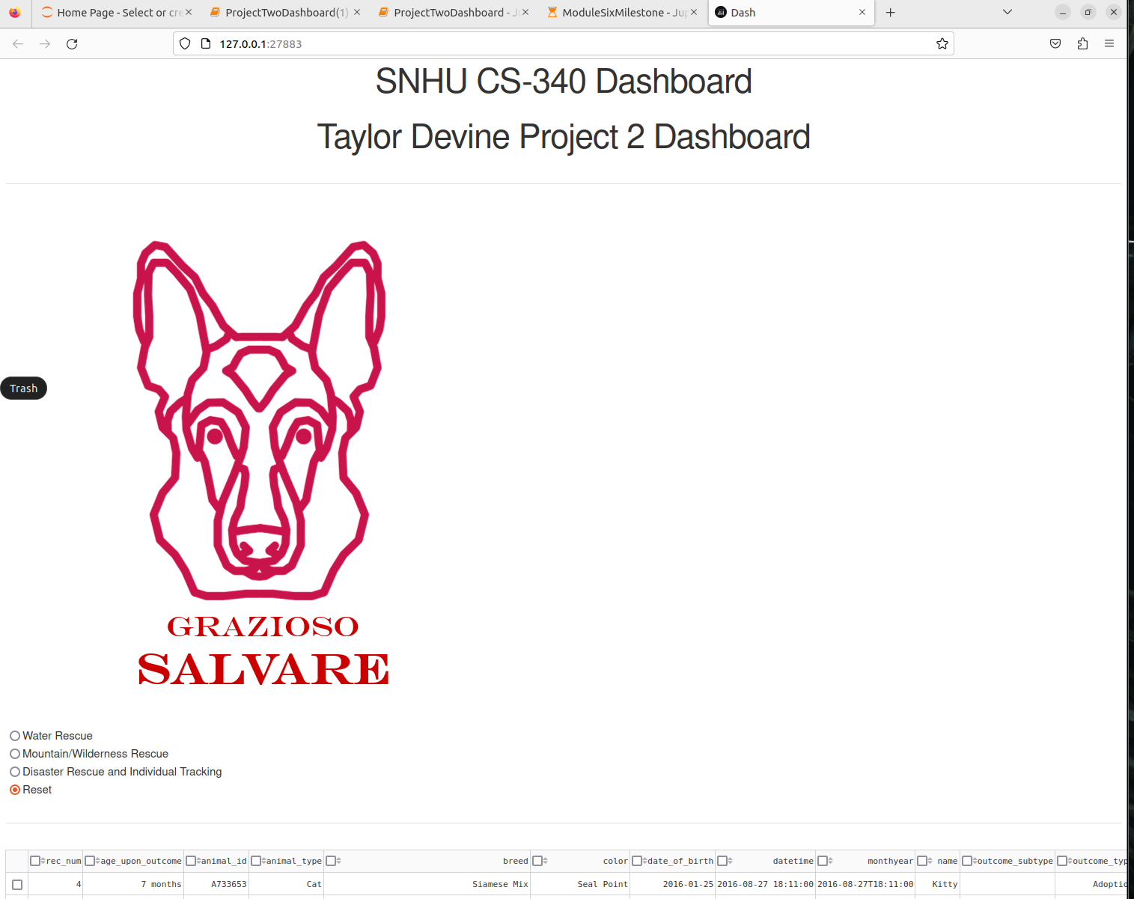

*Filtering options and displays chart with geolocation mapping:*

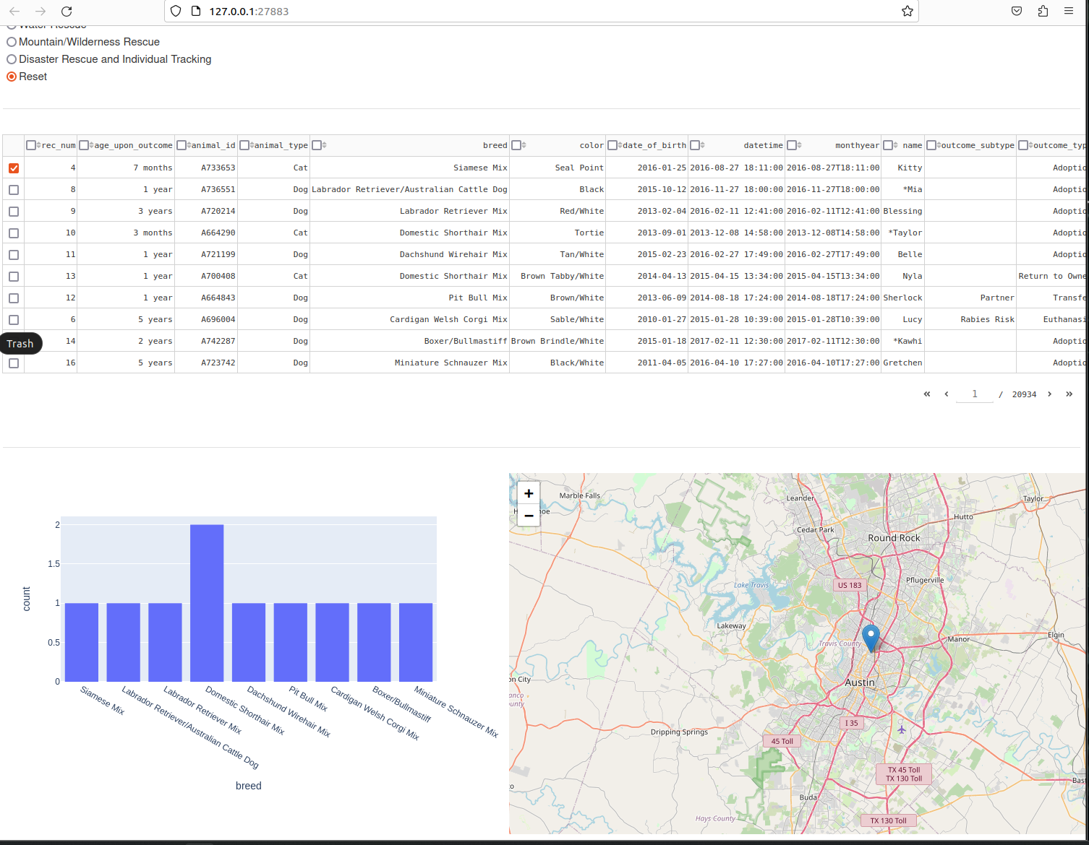

## *Contact*

*Your name: Taylor Devine*